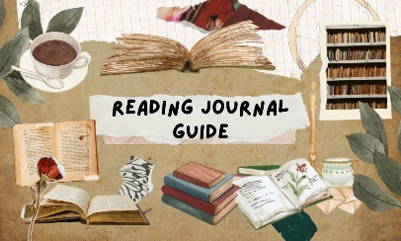

Here is your exciting new reading journal! This reading journal will stay with you throughout your time at Tadley Community Primary School.
How do I use it?
* The reading journal is a place for you to record and review all the books you have read.
* Record the title and author of the book, maybe even the illustrator if you want to.
* It is not to record how many times you have read but how many books you have read.
* It is to be filled out at home and at school, and is for anything you have read.

Review it!
Add a star rating to record your feelings about the book. Keep it simple and make it out of 5. Want to add in more detail? Perhaps write down some thoughts or quotes from the book.
Keep it neat and look after it! It is something you can cherish, to remind you of all the amazing books you have read throughout your years at school.
Examples:



